To access the new Azure Virtual Desktop, please install the "Windows App" on the necessary devices. While the AVD can be accessed via the web, it has limitations, especially with printing.
- Microsoft Windows App from Microsoft Store https://apps.microsoft.com/detail/9N1F85V9T8BN?hl=en-us&gl=US&ocid=pdpshare
May need to make Windows are current if unable to connect to AVD on windows machines as there were some patches in January that caused issues with AVD and Outlook authentication.
- Chromebooks Windows App from Google Store https://play.google.com/store/apps/details?id=com.microsoft.rdc.androidx&hl=en_US
- Apple Windows App from Appstore
https://apps.apple.com/us/app/windows-app/id1295203466?mt=12
Once installed when you open the "Windows App" it will prompt you to sign in with your @afdclinics.com credentials and require MFA on initial connection.

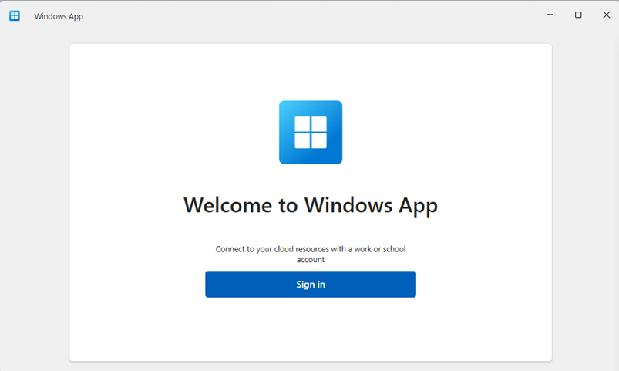

Once you have logged in you will see the available AVD host pool for America's Family Doctors.
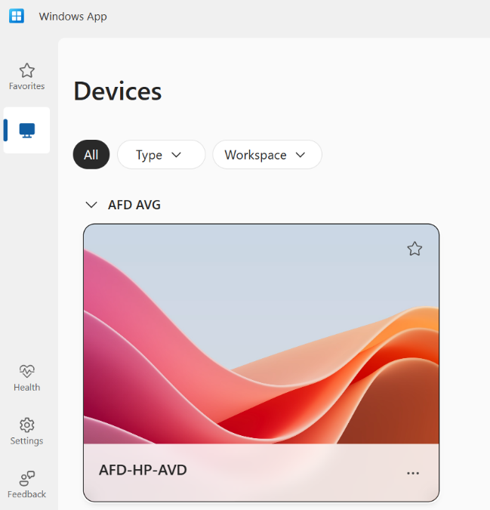
By default, it will open and use ALL DISPLAYS if you use multiple monitors/screens. If you want to change this to have 1 screen so you can work in AVD on one screen and your workstation on another screen, click on the ... in the bottom right, then click on settings. You can turn Off "Use default settings" and set it to All, Single, or Selected Displays.
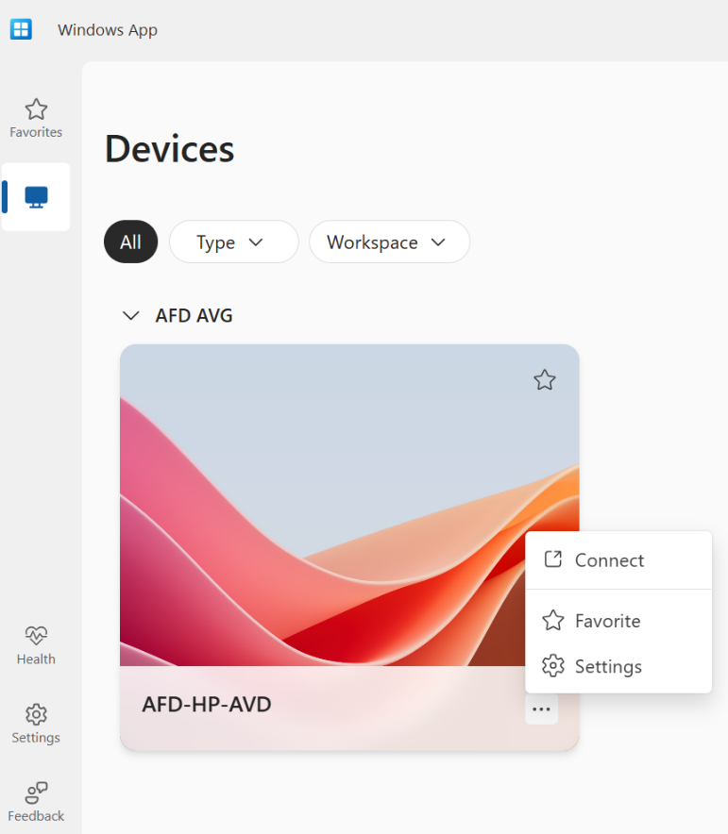
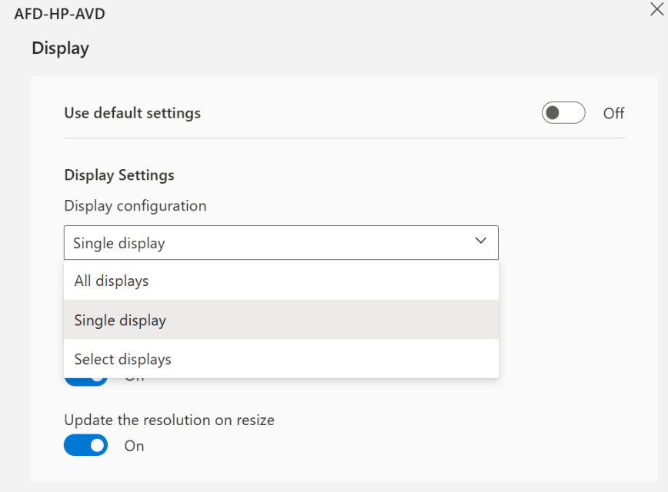

The "Windows App" will keep you logged into your account unless you click on the initials in the top right and select Sign Out. It will however prompt you for your credentials again once you click Connect. This is by design so if you log out you can come back to windows app later and just have to do one login instead of two. After a few days or if you connect from a new physical location, it may prompt MFA again for security reasons.

Click on the AFD-HP-AVD and it will prompt you for your password only since it has already done the MFA and then log you into the desktop.

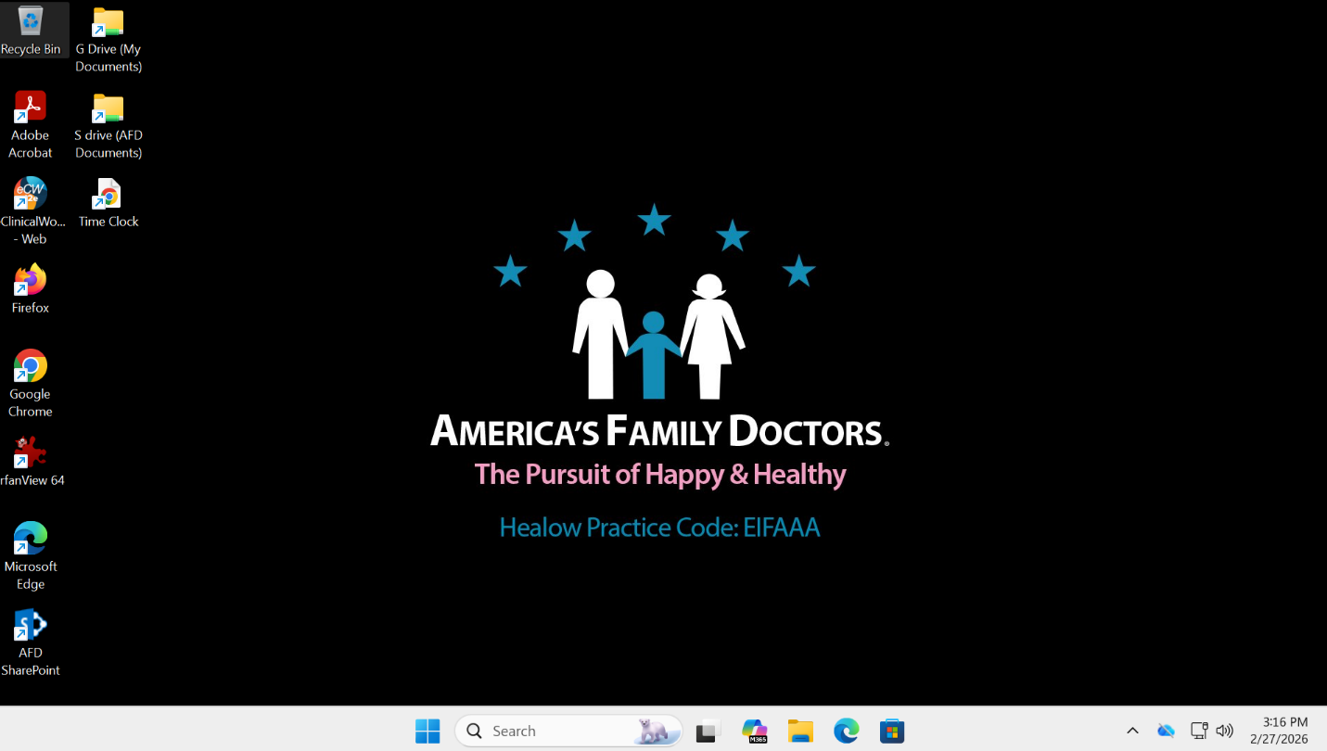

When you are done working, click on the Blue Windows icon on the task bar, click your name, then click Sign Out.

